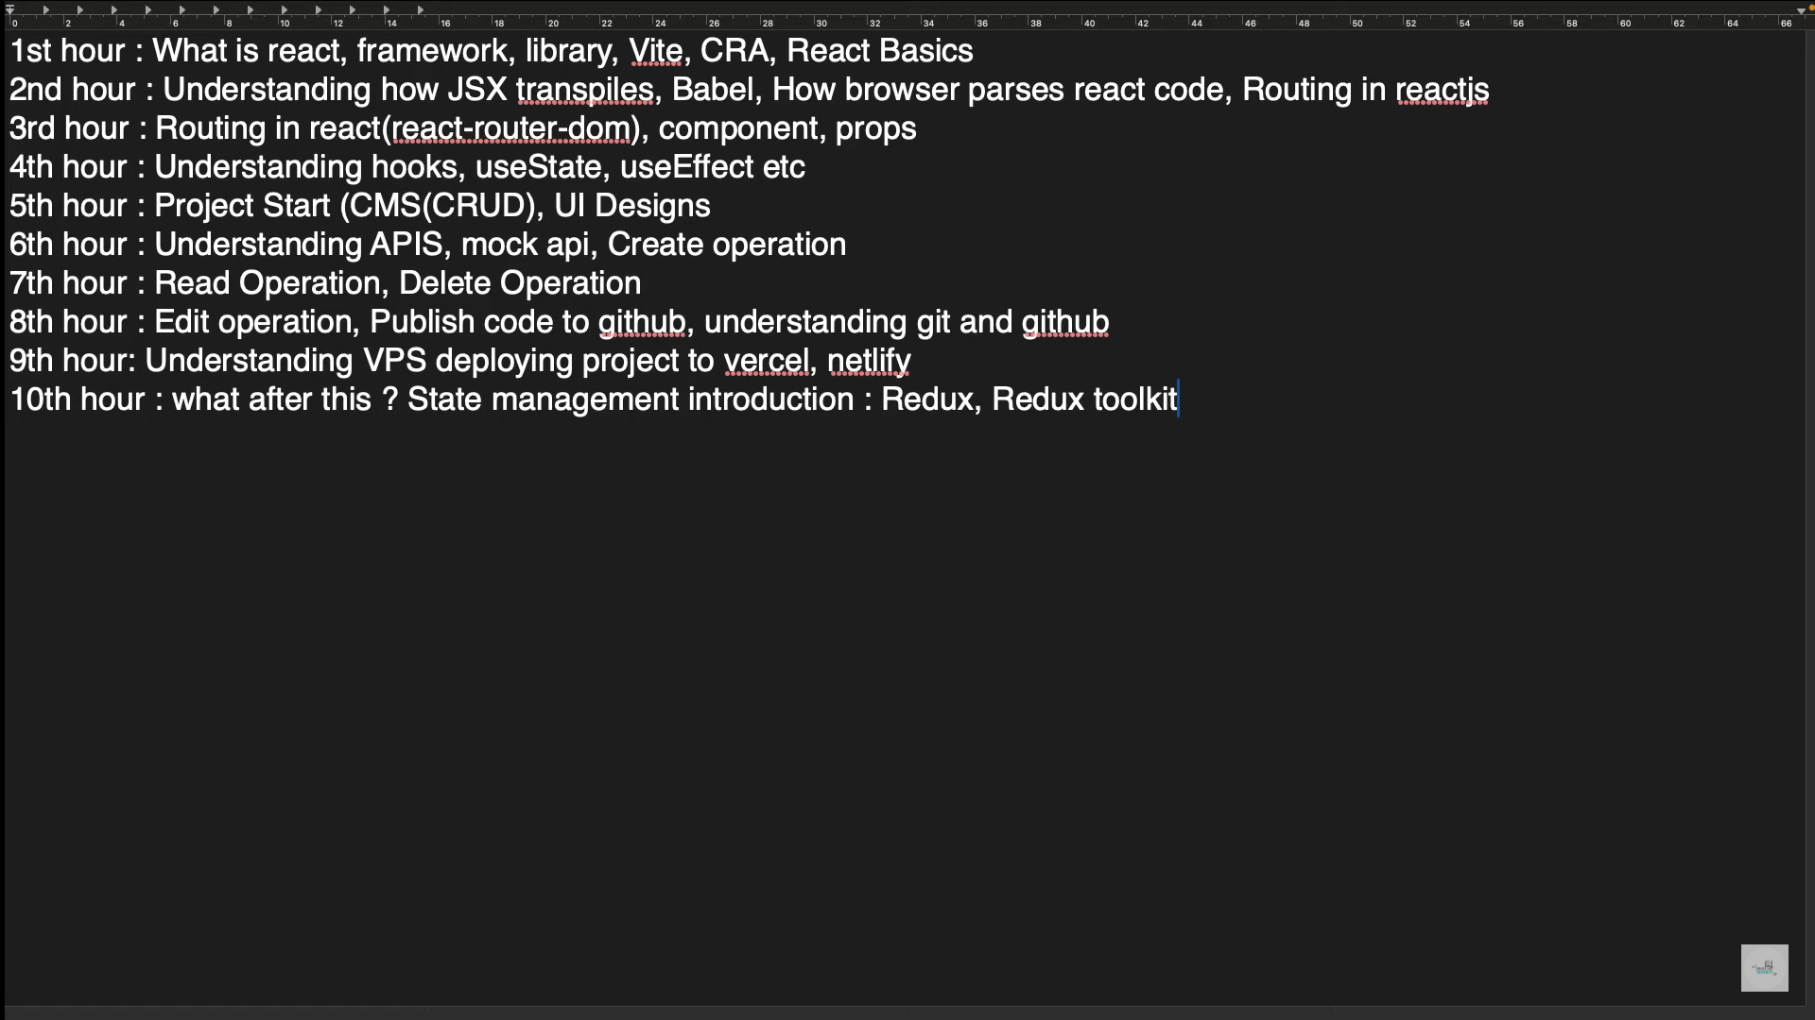

Framework Vs Library: In essence, a framework is like a house blueprint, providing a foundation and guidelines for building a structure. A library is more like a toolbox, offering specific tools for different tasks within that structure.

Farmwork is secure than react.

Library is flexible.

**React**: React is a library. **A Popular JavaScript Library for Building User Interfaces**

**React JS** is a popular JavaScript library primarily used for building user interfaces (UIs) for web applications. It was created and maintained by Facebook and is widely adopted by developers due to its efficiency, flexibility, and component-based architecture.

**Why react over HTML?**

• **Component-based:** React breaks down user interfaces into reusable components, making code more modular and easier to manage.

• **Virtual DOM:** React uses a virtual DOM to efficiently update only the necessary parts of the actual DOM when data changes, resulting in better performance.

• **JSX:** JSX allows you to write HTML-like syntax within JavaScript, making it easier to define and manipulate UI elements.

• **State management:** React provides built-in mechanisms for managing application state, enabling dynamic updates and user interactions.

• **Declarative programming:** React's declarative approach allows you to describe the desired state of the UI, and React handles the updates automatically.

***Vue*** *is framework.*

***Angular*** *is framework.*

**Diffing**: The process of getting difference between current VDOM and pervious VDOM is called diffing.

**Reconciliation**: The process of injecting the difference between VDOM in DOM is called reconciliation.

**Install React JS**

1. Tool **Vite** or Create React App (CRA)

***We’re using Vite for React set up. Vite is fast in comparison to CRA but CRA is good for big projects and Vite is use for intermediate project.***

**Command to install React**: npm create vite@latest

To use same directory folder: ./

**Done. Now run:**

npm install

npm run dev

***The file extension of React is .jsx***

**<>**

      <h1>Haha</h1> ---🡪 This is not HTML tag, this is jsx

      <h1> {1+2} </h1> ---🡪 Value inside Curley braces will be calculated and it’ll return 3.

**</>**

**Compilation** involves translating high-level programming language code directly into machine code. This machine code is specific to a particular hardware architecture and can be executed directly by the CPU.

**Transpilation** is the process of converting a language into an equivalent version of the same language. Modern JavaScript can be transpiled into older syntax, making it compatible with older browsers.

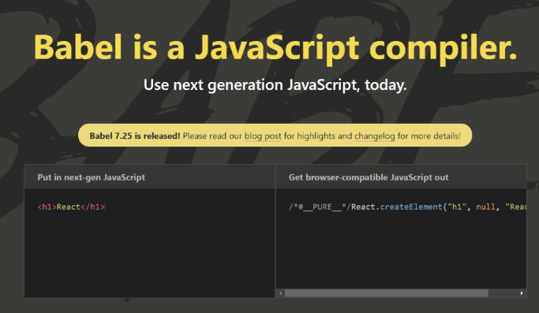

**Babel: A JavaScript Compiler**

**Babel** is a popular JavaScript compiler that allows developers to use newer JavaScript syntax features in their code, even if the target environment doesn't support them natively. It's often used to write code in the latest ECMAScript (ES) standards while ensuring compatibility with older browsers or environments.

**Key Features of Babel:**

* **Transpilation:** Babel can transpile modern JavaScript code into a version that is compatible with older browsers or environments. This means you can write code using ES6+ features like arrow functions, classes, and modules, and Babel will convert it into ES5 code that can be understood by older browsers.

**Project Development (Project Management System)**

**How any project is deal in any company?**

1. Project

2. Project discussion by manager

3. Project final

4. Project division to different teams like [UI/UX, Frontend, Backend, Security Testing Team, Quality Assurance (QA)]

**API**

**API** stands for **Application Programming Interface**. It's a set of rules and protocols that allow different software applications to communicate with each other. Think of it as a bridge that connects two applications, enabling them to exchange data and perform tasks.

**Key components of an API:**

* **Endpoints:** These are the specific URLs that applications use to interact with the API. They define the actions that can be performed.
* **Requests:** These are messages sent by one application to another through the API. They typically include information about the desired action and any necessary data.
* **Responses:** These are the replies sent back by the API in response to a request. They contain the results of the action or any relevant information.
* **Documentation:** This provides detailed information about the API's endpoints, request/response formats, and usage guidelines.

**Types of APIs:**

* **Public APIs:** These are APIs that are publicly accessible to anyone.
* **Private APIs:** These are APIs that are only accessible to authorized users or applications.
* **Partner APIs:** These are APIs that are shared between partner companies.

**Examples of APIs:**

* **Google Maps API:** Allows developers to embed maps into their applications.
* **Twitter API:** Enables applications to interact with Twitter data.
* **Payment gateway APIs:** Facilitate online payments.

**In essence, APIs are the building blocks that enable different applications to work together and share information.**

**Integrate Tailwind with vite**

**Follow this link**: <https://tailwindcss.com/docs/guides/vite>

**Integrate Tailwind CSS in React Js with vite**

Follow this link: <https://tailwindcss.com/docs/guides/vite>

npm install -D tailwindcss postcss autoprefixer

npx tailwindcss init -p

**To create dynamic API:** [**https://mockapi.io/**](https://mockapi.io/)